Document ID: 09_21_05_1
Date Received:2005-05-21 Date Revised:2006-06-14 Date Accepted: 2006-06-16
Curriculum Topic Benchmarks: M4.3.3, M4.3.4, M4.3.5, M4.3.6, M4.3.10, M4.3.19, M4.4.4, M 4.4.5, M4.4.6, S15.4.4, S15.4.5, S15.4.6 (primarily for Extension activities)
Grade Level: Middle School [6-8]
Subject Keywords: laser, interference pattern, fringes, wave nature of light
Rating: Advanced

Seeing Interference Fringes

By: Stephen J Edberg, Jet Propulsion Laboratory, California Institute of Technology, 4800 Oak Grove Drive, M/S 301-486, Pasadena CA 91011
e-mail: Stephen.J.Edberg@jpl.nasa.gov

From: The PUMAS Collection http://pumas.jpl.nasa.gov
©2006, Jet Propulsion Laboratory, California Institute of Technology.
ALL RIGHTS RESERVED. Based on U.S. Gov't sponsored research.

OBJECTIVE: Demonstrate the wave nature of light by projecting interference patterns. Detecting the interference of waves is one of the most powerful methods in science for measuring wave phenomena, and using the waves and their interference can reveal underlying details of their sources and the materials through which they travel. Some examples of applications include:
Geography (mapping) – Satellites orbiting Earth can make radar maps of the surface, and by repeating the same orbital path later, data collected during both passes can be combined to illuminate changes in altitude of seismically active regions. Images are made by combining the before and after views to produce “interference patterns” that are very sensitive to small changes. The changes of the Earth’s surface are the equivalent of changing the slit width or slit spacing in the PUMAS experiment described here.
Seismology – Radar mapping before and after an earthquake has been used to show actual fault slippage. Again, the pattern produced by combining ‘before’ and ‘after’ views highlights tiny changes that can indicate position changes and stress patterns in Earth’s crust.
Astronomy and Astrophysics – Vibration patterns – waves at many frequencies and their interference – measurable on the solar photosphere indicate details of its structure deep down. Arrays of radio telescopes and arrays of optical telescopes combine the waves they collect – much as slits in this experiment transfer waves – and can be used to make extremely high resolution images and measurements of celestial objects.
High Energy Physics – Studies of subatomic particles use the wave nature of their particle-wave duality to demonstrate subtle differences that have great implications for the structure of the universe.

Underlying principles are explained in Appendix 1. Extensions to this lesson are found in Appendix 2.

APPARATUS: (1) Laser pointer – available from some discount, photography, and stationery stores or by mail order; red is preferred for safety reasons but green works better if the room cannot be darkened well; be sure to block reflections of laser light.
- Small piece or scrap of second surface mirror – the kind used in a bathroom mirror with the silvery, reflecting surface underneath the glass; a hardware or glass store may have scraps available.
- Four binder clips from a stationery store.
- Single edge razor blade from a hardware store.
- Ruler or straight edge.
- Projection screen, or white wall or sheet of paper for use as a projection screen (a glossy surface should be avoided).
- Flat work surface.

PROCEDURE: Use a razor blade and straight edge to make a straight, clean, narrow scratch (scrape, really) that removes the paint from the back of the second surface mirror but doesn't scratch the glass. Then make a second one parallel and a millimeter or less from it. Then, about an inch or more away from this pair of slits, make a single slit. If the first attempt doesn’t succeed, try again: start in a corner of the mirror so there is practice room until there is a good single slit and a good pair of slits. Be careful of sharp edges when working with the blade and the glass.

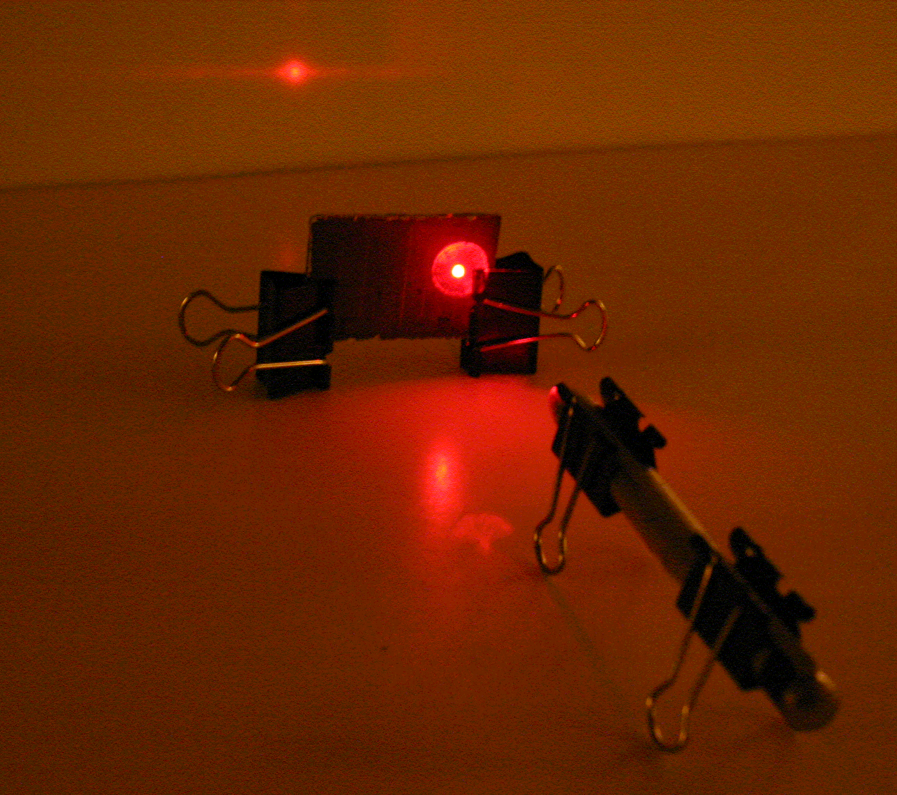

Figure 1: The laser beam passes through slits scraped on the back of the mirror from its painted side onto the screen. Binder clip “legs” support the laser and slits (mirror) on the table. Reflections are seen below the slit and to the left of the laser. The interference pattern is on the background screen.

Alternatively, heavy aluminum foil can be used. Cut slits through it with the blade, using cardboard to protect the table top and permit penetration of the foil. Don’t push down too hard with the blade: a narrow slit is desired. It may be convenient to wrap, carefully, the aluminum foil around a clear piece of glass after the slits are made. (In use, send the laser beam through the foil first.)

Use a pair of binder clips to serve as legs supporting the laser and to hold its switch on. Use another pair of clips to hold up the piece of second surface mirror with the slits. Adjust heights so the laser beam will pass through the slit(s).

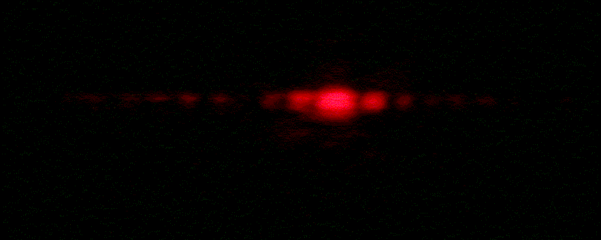

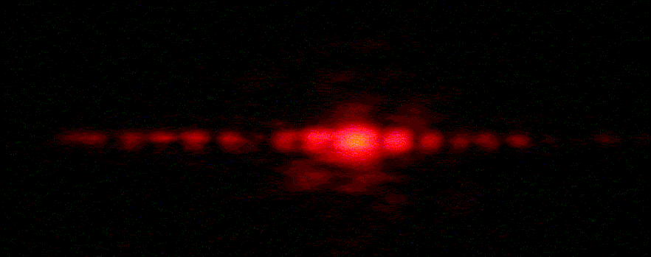

Figure 2: Different exposure times, shorter (top) and longer (bottom) were used to photograph these single slit patterns. If a pinhole had been used instead of a slit, the patterns would look like a bulls-eye target – the Airy pattern seen by astronomers in their telescopes.

In a dark room, aim the laser beam through the slits on the painted side of the mirror so that the beam projects through the mirror onto a wall (or screen). First, send the beam through a single slit to make a single slit diffraction pattern. This linear pattern is like a section through the bull’s eye-like Airy pattern. The Airy pattern is seen by astronomers using high magnification to look at a star image through a telescope.

Now project the laser beam through the double slit to make an interference pattern on the wall. This “fringe” pattern is different, with more bright spots (maxima) and dark separators (minima) along the line of light. A careful examination may reveal that the spots are modulated by a single slit pattern: the brightest maxima are in the middle of the line. Looking outward in either direction, the maxima get fainter, to some minimum, and then get brighter again, and then fade away. (The room has to be dark enough and the laser bright enough or the screen close enough for this to be visible. Sometimes the beams from inexpensive laser pointers are not good enough to make a good double slit pattern.)

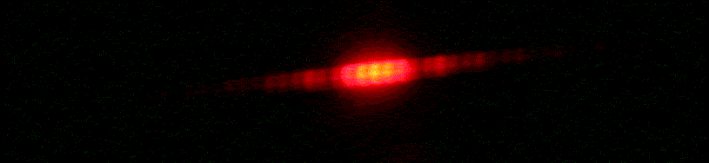

Figure 3: This is a double slit interference pattern made with an inexpensive laser. Note how there are additional maxima and minima of brightness, caused by the interference of light coming through the two slits. The single slit interference pattern modulates the brightness of the double slit pattern.

FOR MORE INFORMATION: See the discussion and pictures at http://en.wikipedia.org/wiki/Double-slit_experiment for an explanation and illustration of the double slit interference pattern you should be seeing.

Another example is
http://schools.matter.org.uk/Content/Interference/laserinterference.html that permits you to change slit width, slit separation, and projection distance.

The website http://hyperphysics.phy-astr.gsu.edu/hbase/phyopt/mulslidi.html graphs the brightness of the interference pattern (brightness is left-right, distance along a screen is up-down) for one slit or two slits (or more) and allows you to include diffraction (Airy pattern) in the interference pattern by clicking on what you want. It shows, just barely, the secondary maxima and the striping.

PUMAS Document 09_21_05_2, Seeing Interference Fringes with a Telescope, gives instructions on observing fringes of stars with small and medium size telescopes.

There are links to the science, technology, and history of interferometry at http://planetquest.jpl.nasa.gov/SIM/sim_index.html .

REFERENCE: http://www.physics.uoguelph.ca/applets/Intro_physics/kisalev/java/slitdiffr/

ACKNOWLEDGMENT: This publication was prepared by the Jet Propulsion Laboratory, California Institute of Technology, under a contract with the National Aeronautics and Space Administration.

Reference herein to any specific commercial product, process, or service by trade name, trademark, manufacturer, or otherwise, does not constitute or imply its endorsement by the United States Government or the Jet Propulsion Laboratory, California Institute of Technology.

Appendix 1

THE UNDERLYING PRINCIPLES: Waves of the same type, whether they are water, light, sound, seismic waves from an earthquake, or any of a multitude of others, interfere with each other when they cross paths. Consider the rings made when a small ball is dropped into a quiet swimming pool, and how the waves reflect at the wall of the pool. The reflected waves may cross paths with waves still moving towards the wall and create interesting patterns due to interference.

Where a “peak” crosses a “peak,” the waves add:

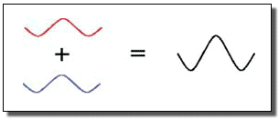
Figure 4: Constructive interference.

Where a “valley” crosses a “peak,” the addition yields no amplitude, zero signal:

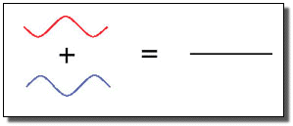
Figure 5: Destructive interference.

Water waves expanding from a dropped pebble in a pool are said to have circular wave fronts; those from the laser source are straight lines (perpendicular to the direction of the laser beam) and are called “plane” waves.

The laser light waves are blocked downstream, except that they can pass through the slit(s). As the waves pass through the slit or slits, they form new circular wave fronts at each point across the slit. These waves interfere. But there are no waves to interfere with those at the edges, so not far downstream from the slit itself, there are only circular waves from each edge of the slit(s). It is easy to envision the circular wave fronts interfering when they come from two slits. The same is true, in fact, for waves coming from either side of a single slit. So interference patterns are formed by both single and double slits.

Appendix 2

EXTENSION: You can use a needle to make a small hole in aluminum foil. Project the laser beam through the hole to create an Airy pattern on the screen. Beware of laser reflections off the foil going into eyes. The spacing between rings is different for different colored lasers (and would be different if one were looking at a star’s pattern with color filters through a telescope).

Try looking through the single slit and then the double slits at a tiny, high intensity flashlight bulb (reflector removed from the flashlight) at a distance of 3 to 5 meters (10 to 15 feet) to see their different interference patterns. The brightness of the bulb may leave an after-image in your vision which should disappear in a short time. You may need to move closer to or farther from the slits to see the patterns.

Now try with a light emitting diode (LED) at increasing distances starting at 1 meter to see at what distance fringes appear. Use an LED that is not uncomfortably bright, or place one lens from a pair of sunglasses between you and the LED to reduce the intensity.

Albert A. Michelson measured the sizes of stars with his interferometer mounted on the Mt. Wilson 100" Hooker Telescope in 1921: he determined the aperture spacing that produced fringes and the largest spacing that did not produce fringes and from that could deduce the angular diameter of a few bright, large stars. Looking at LEDs at different distances mimics Michelson’s star measurements because the LED changes its apparent angular size with distance, and between resolvable (disk visible as seen through the aperture) and unresolvable (disk too small to be seen as larger than point-like).

Look at LEDs of different colors to see differences in the spacings of the fringes. DON'T EVER LOOK INTO A LASER BEAM – your eyesight can be damaged permanently.

Measure the width of the single slit or the separation of the slits in the pair. For a single slit the equation

sin θ = $\frac{n×λ}{w}$ (1)

describes the angle, θ, from the direction of the beam to the minima in brightness, numbered n = 1, 2, … outward on either side of the maximum brightness spot for a slit width of w and a light source of wavelength λ.

Equation (1) can be rewritten, using the definition of sine, the Pythagorean theorem, and variables in the diagram below:

$\frac{R}{\sqrt{(R×R)+(D×D)}}$ = $\frac{n×λ}{w}$ (2)

R
D
θ
Peak Brightness
First Minimum
Screen
Slit

Figure 6. Geometry of a single slit interference pattern display. Laser light coming from the left through the slit forms circular wave fronts that interfere at the screen on the right.

Rearranging (2), the slit width can be measured if λ, R, and D are known (and n = 1 is chosen).

w = $n×λ\frac{\sqrt{(R×R)+(D×D)}}{R}$ (3)

Red lasers typically have a wavelength, λ = 670 nanometers (confirm from the notice on the laser or with the packaging). The distances D and R can be measured with a ruler. Slight errors will be introduced by the glass and if the laser wavelength is not known to great accuracy. Measuring to more distant minima (i.e., n > 1) will improve the precision of the slit width determination and is a good demonstration of ways to reduce measurement error.

The expressions for a double slit are almost exactly the same. The length R is now the separation from central maximum to outer maxima and w is now the separation between slits.

