Curriculum Topic Benchmarks: M1.4.1, M2.4.6, M3.4.3, M4.4.6, M4.4.8, M5.4.17
Grade Level: High School [9-12]
Subject Keywords: Area, Estimation, Proportion, Geometry, Surface Area, Scaling
Rating: Moderate

Estimation of Planar Areas Using Analogue Methods

By: Dr. Philip Gabriel, Colorado State University, Dept. of Atmospheric Science, Fort Collins, CO, 80521. S. Kathryn Grimes, Poudre School District, Fort Collins, CO, 80521
e-mail: gabriel@atmos.colostate.edu, skathryngrimes@comcast.net

Purpose
To determine areas of simple and complex planar figures using measurement of mass and proportional constructs.

Materials
- Poster board or oak tag
- Scissors or other precise cutting tool
- Ruler
- Sharp pencil
- Right angle
- Analytical balance (0.1 milligram readability)

Procedure
Using a sharpened pencil, ruler and right angle, draw a square on the poster board or oak tag.
Cut out the square precisely. The size of the square should fit inside the weighing pan (for the examples below, we used a Mettler AB204-S analytical balance).
Draw and cut out other shapes of interest as suggested by the illustration below.

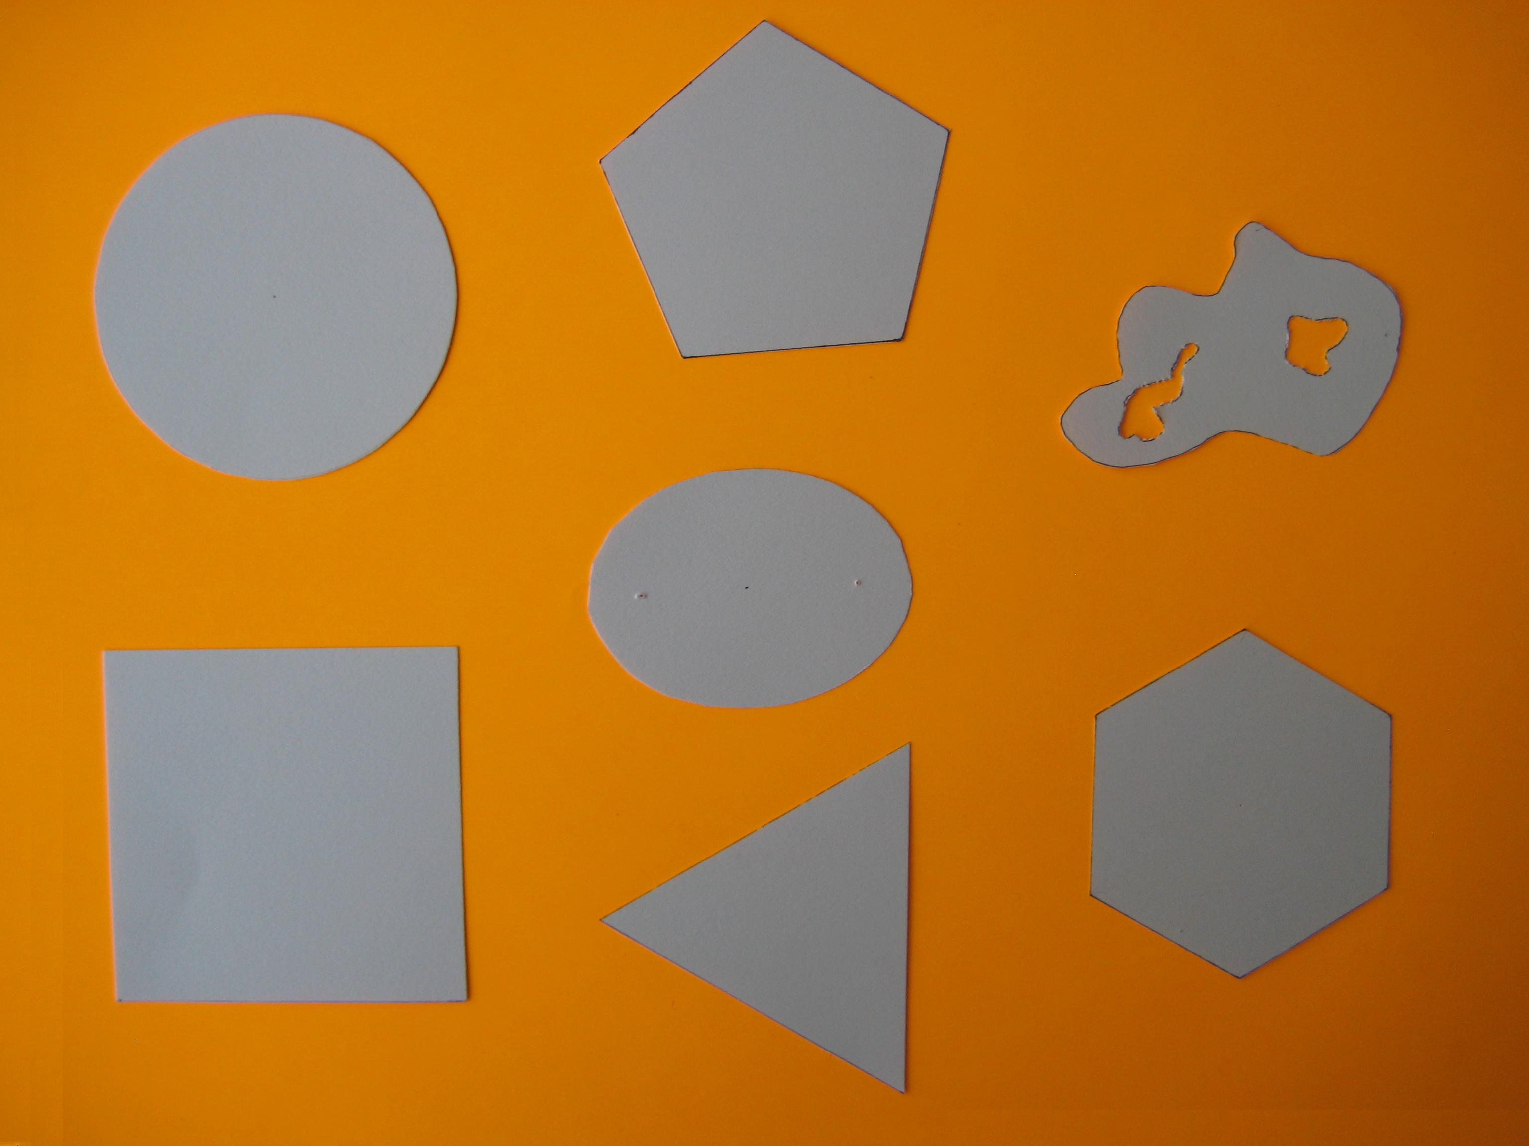

Fig. 1 Circle: diameter=2.50 inches, mass=0.5920 grams; Square: side=2.50 inches, mass=0.7329 grams; Regular Pentagon: side=1.50 inches, mass=0.4551 grams; Ellipse: semi-major axis=2.25 inches, semi-minor axis=1.6563 inches, mass=0.3385; Equilateral Triangle: side=2.50 inches, mass=0.3203 grams; Irregular: extreme dimensions=2.625 inches, 1.75 inches, weight=0.2819 grams; Regular Hexagon: side=1.25 inches, mass=0.4844 grams

Turn on balance and allow for it to warm up according to its specifications. Weigh each shape to determine its mass, recording each value. Infer the area of each figure using the proportion:

Results
Using the simple proportion, we inferred the areas shown in table 1.

Shape | True Area | Inferred Area | % Error
Circle | 4.9087 | 5.0484 | 2.8459
Square | 6.2500 | - | -
Pentagon | 3.8711 | 3.881 | 0.2554
Ellipse | 2.9268 | 2.8866 | 1.3730
Triangle | 2.7063 | 2.7314 | 0.9280
Irregular | - | 2.4040 | -
Hexagon | 4.0595 | 4.130 | 1.7576
Table 1. Summary of the shapes used in calculations of areas.

Discussion
The inferred areas can be seen to agree well with the theoretical values. The square is used as a standard from which all other areas are derived because its simple geometry can be cut out very precisely, hence its area can best approximate the theoretical value that is given by the square of the length of a side. The theoretical area of the irregular figure is unknown because it is the object of this lesson to demonstrate how one might simply calculate the area of a complex shape that may defy analytic tractability.
To understand the sources of error, thickness measurements of each shape were taken randomly using a micrometer capable of measuring to within 50x10⁻⁶ inches. The histogram in figure 2 shows that the variation in thickness appears to span a small range: the standard deviation of the oak tag thickness is 1.2223 x10⁻⁴inches. Its mean thickness is 9.600 x10⁻³inches, or approximately 78 standard deviations! This means that the oak tag is essentially uniformly thick. Thus the source of error lies not in variations in thickness, but must be attributed to errors in cutting out the figures.

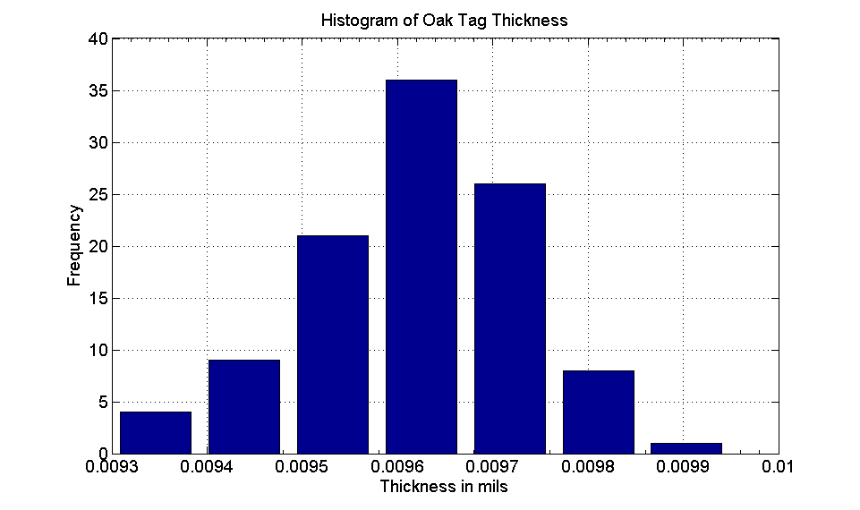
Fig. 2 Histogram depicting oak tag thickness variations.

Conclusion
A method for calculating simple and complex planar areas is described in this lesson. The method involves using a balance to weigh shapes of interest and a proportion of the area to the weight of a square to calculate the area of the shape of interest. This is useful because of its generality: areas of regions that are not analytically tractable can be readily estimated. The accuracy is limited mainly by the precision of cutting the shape’s boundary. To rescale the area it is simply necessary to multiply the minimum and maximum dimensions by an appropriate scale factor.
For instance, considering first the circle, by letting radius r->λr, the area is rescaled by a factor of λ². If λ>1, the area is enlarged. If λ<1 the area is contracted. In the case of an ellipse, if the semi-major ‘a’ axis is rescaled to ‘λa’ and similarly the semi-minor ‘b’ axis ‘b’ is rescaled to ‘λb’, the area of the ellipse pi*(a*b) is rescaled to λ²*pi*(a*b). The same principle applies to irregular shapes, the only difference being that the minimum and maximum dimensions are rescaled, and in so doing, result in a corresponding rescaling of the area by the factor λ².

Practicality
Regarding the practicality of the method, one of us (PG) has applied this technique to the calculation of complex planar areas that were used in a peer reviewed paper¹. It was a time saving method that yielded very good accuracy.

1. Gabriel, P., H. W. Barker, D. O’Brien, N. Ferlay and G. L. Stephens. 2009. Statistical Approaches to Plane-Parallel Error Identification and Retrievals of Optical and Microphysical Properties in 3D Clouds Part 1: Bayesian Inference. J. Geophys. Res., 114, D06207, doi:10.1029/2008JD011005.

