Document ID: 08_18_00_1
Date Received: 2000-08-18 Date Revised: 2000-11-09 Date Accepted: 2000-11-09
Curriculum Topic Benchmarks: S6.4.8, S15.4.1, S15.4.5, S15.4.6
Grade Level: [9-12] High School
Subject Keywords: aviation, eyes, vision, anatomy, physiology, psychology, optic disc
Rating: moderate

Now You See It, Now You Don’t

Demonstrating Visual Deficiencies Inherent to the Anatomy of the Eye

By: Charles R. “Chuck” Moren, Associate Professor of Aeronautical Science,
Embry-Riddle Aeronautical University, Daytona Beach, Florida 32114.
e-mail: morenc@cts.db.erau.edu

From: The PUMAS Collection http://pumas.jpl.nasa.gov
©2000, California Institute of Technology. ALL RIGHTS RESERVED. Based on U.S. Gov't sponsored research.

Objective: A demonstration of the effect of the optic disc, or “blind spot,” inherent to the optic nerve entering the posterior of the eye (bulbus oculi).

Application: This demonstration works well at all levels of instruction involving the anatomy of the eye. It lends itself very well to basic anatomy and/or physiology classes. It is also appropriate for introductory psychology classes during discussions of vision and visual perception. I use it in my flight physiology class during discussions concerning night vision and visual illusions. The demonstration only takes a few minutes and is a “real attention getter.”

Equipment required: One (1) piece of 8.5-inch by 11-inch plain paper and one (1) pen or pencil, per student. Optional: One (1) piece of 8.5-inch by 11-inch ruled paper or graph paper, per student.

Applicable Anatomy/Physiology: Light, in the form of wave energy, enters our eye and stimulates light-sensitive receptor cells called rods and cones. The rods and cones are located at the posterior of the eye in nerve tissue referred to as the retina. When the light reaches these cells, the cells generate nerve impulses that travel through the optic nerve to the occipital lobe of the cerebral cortex of the brain. The brain then interprets the information and creates an image that we “see.”

Optic Disc: The optic nerve enters the posterior of the eye through the retina. There are no rods or cones located in the area where the optic nerve penetrates the retina. This circular area is referred to as the optic disc. Because of the absence of rods and cones, the optic disc causes a blind spot near the center of the retina.

Demonstration: On a blank sheet of paper (copy paper works great) draw an asterisk the size of a dime in the upper left and upper right corners of the paper. The asterisk should be about 2 inches from the top and 2 inches from each side.

With your right hand, cover your right eye. Hold the paper in front of your face approximately 14 inches away with the RIGHT asterisk in front of your LEFT eye. The left asterisk will disappear in the blind spot.
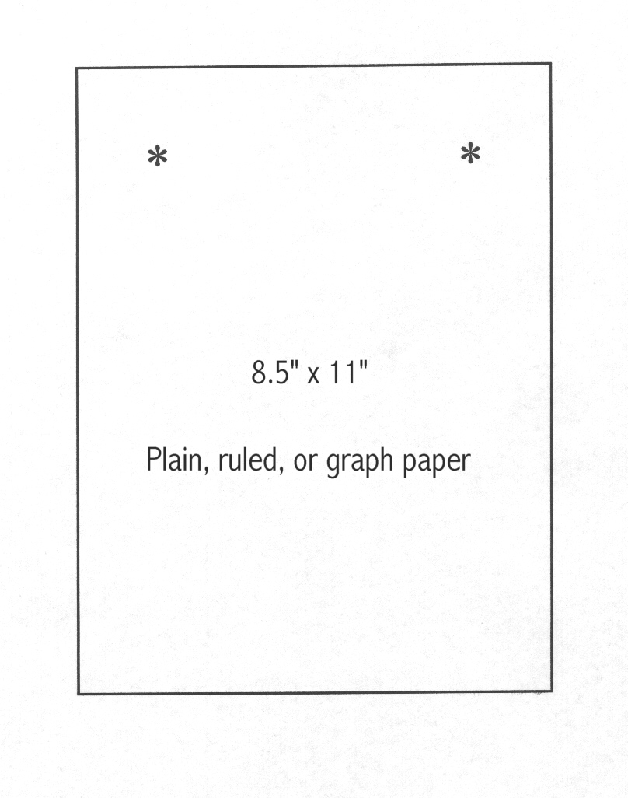
You may need to vary the distance several inches or move the paper side to side slightly to find your blind spot. Be sure to look directly at the RIGHT asterisk.

When doing the demonstration in class, either draw a piece of paper on the board and show the location of the asterisks or hold up a piece of paper after you draw the asterisks on it. Demonstrate the process by doing. The students will understand the process faster if they can duplicate your actions. Listen for the WOWs !!

You can use lined notebook paper. Just have the students take out a sheet of paper and proceed as above.

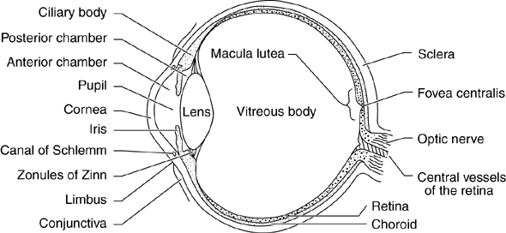

Background: Our ability to “see” is a complex process that is often taken for granted. For those of us who have the use of all five of our senses, the majority of information stimulus about the world around us enters our sensory system through the sense of vision. Thus, anything that disrupts the normal visual process can have a significant effect upon our ability to maintain our situational awareness. Many of us have seen illustrations in textbooks that demonstrate visual illusions. These illustrations demonstrate that our perceptions can be tricked by visual stimulus that is improperly interpreted by our brain. The first significant interpretation that always occurs in the brain is the inversion of the image. Because of the properties of the lens of the eye, the light entering the eye is turned upside down. However, thanks to our brain, we see the upside down stimulus as something that is right side up. Most visual illusions are caused by the brain and not by anything inherently wrong with our eyes. True visual illusions occur when the brain has difficulty interpreting data received from the eye and not by a malfunction of the eye itself. This demonstration is unique because it shows a deficiency in the function of the eye itself.

Retinal Disparity: Most of us go through life without ever seeing our blind spots. The optic nerve is not located in the exact center of the retina. The optic nerve of the right eye enters slightly to the left of center and the optic nerve of the left eye enters slightly right of center. In other words, the location of the optic disc is different in each eye. Because our eyes are not located on the exact centerline of our body, when we look at an object, light waves reflected from that object are projected onto the retina of each eye in a slightly different position. This is referred to as retinal disparity. Retinal disparity allows our brain to receive the entire image reflected from the object. The left eye captures the portion of the image that is missed by the optic disc of right eye, and visa versa. At short distances, retinal disparity also provides binocular cues for depth perception.

Practical Application/Discussion

Night Vision: Cones are stimulated by bright light and do not function at low light levels. Rods function at low light levels, after a period of adaptation. During the adaptation period, a chemical called rhodopsin is produced by the rods (rhodopsin is destroyed by bright light). Night adaptation occurs over a 30-45 minute period. This is the improvement in night vision that we recognize after sitting in a dark theater for a period of time.

On the retina of the eye, the cones surround the optic disc in the area known as the Fovea centralls. The rods surround the cones. At low light levels, when the cones stop functioning, the size of the blind spot (now, the area of the optic disc plus the non-functioning cones) increases significantly. An unlighted object twelve inches in diameter cannot be seen at night at a distance of 30 feet or more. At 3000 feet, a large aircraft will be invisible. Although this demonstration does not specifically show the effects of night vision, it can be a great introduction to the subject. Pilots are taught a concept called off-center viewing that can be used at night to help overcome the effects of the increased size of the blind spot. Pilots do not look directly at what they want to see outside of the aircraft, they look at a point about 10 degrees to one side of where they expect to see an object. Throughout our lives, we develop a habit of looking directly at what we want to see, and it requires conscious effort to overcome this center-viewing habit. This demonstration introduces the effects of the blind spot in a way that clearly demonstrates the limitations of the eye, and the need and importance of off-center viewing is reinforced.

Other Precautions: You may point out the danger of operating a motor vehicle if one eye is covered, such as after an injury to the eye. In addition to the deficiencies caused by the blind spot, covering one eye also causes problems with depth perception at distances up to approximately 50 feet.

Perceptual Constancy: When using lined paper (or graph paper, if available), notice that the line(s) appears to continue through the area from which the asterisk has disappeared. The brain has interpreted the lines as continuing through the area because it thinks they "should be there," based upon a lifetime of learning. This phenomenon is referred to as perceptual constancy.

Bibliography:
Department of the Air Force, (1976). Physiological Training. Washington, D.C.

Edwards, L. F. and Gaughran, G. R. L. (1971). Concise Anatomy (3rd ed.). New York: McGraw-Hill.

Reinhart, R. O. (1996). Basic Flight Physiology (2nd ed.). New York: McGraw-Hill.

Wade, C. and Tavris, C. (1995). Psychology (4th ed.). New York: HarperCollins.

