Document Id: 01_31_10_1
Date Received: Date Revised: Date Accepted:
Curriculum Topic Benchmarks: S1.2.1, S1.2.3, S1.3.4, S1.4.1, S1.4.2, S11.3.3, S11.3.4
Grade Level: Middle School [6-8] or High School [9-12]
Subject Keywords: clouds, air, energy, climate change, light scattering
Rating: Moderate

Aerosol-Cloud Interactions in a Beaker

By: Richard Moore, School of Chemical and Biomolecular Engineering
Georgia Institute of Technology, 311 Ferst Drive NW, Atlanta, GA 30332
e-mail: richard.moore@chbe.gatech.edu

From: The PUMAS Collection http://pumas.nasa.gov
© 2010 Practical Uses of Math and Science. ALL RIGHTS RESERVED. Based on U.S. Gov’t. sponsored research

Materials:
600-1000 mL beaker or glass jar
zip-lock bag of ice
source of warm but not boiling water (directly from sink or heated using hot plate)
matches or small piece of cardboard/paper and lighter
laser pointer

Background:

Have you ever noticed that cloudy days feel cooler than sunny days, but that cloudy nights feel warmer than clear nights? The reason has to do with how clouds absorb and reflect energy. During the day, some of the incoming sunlight bounces off of the top of the clouds and back into space. Normally this sunlight energy would have been absorbed by us and also by the Earth’s surface, thereby increasing our energy, and this increase in energy makes us feel warm. However, on a cloudy day, less sunlight reaches the surface where we are, less energy is absorbed, and we feel cooler. At night the situation is reversed because the sun is no longer a source of energy, but the Earth is. On a clear night, the Earth’s energy is radiated out to space as heat and is lost. But on a cloudy night, the clouds absorb some of this outward-radiated heat energy, trapping it at the surface and we feel warmer.

This simple example explains how clouds can affect us at the local level, but scientists throughout the world are currently studying how clouds may have a substantial cooling effect on the entire globe. Again, this is because clouds reflect some of the sun’s energy back to space, which would otherwise be absorbed by the surface. If humans have changed global cloudiness over the past century, and thus cooled the planet, this could affect how they predict future climate change caused by global warming. To understand how people may have affected cloudiness, it’s useful to look at how clouds form in the first place.

Clouds consist of tiny water droplets suspended in air, which form when humid air is cooled enough that some of the gaseous water becomes a liquid. This is sometimes explained by saying that “the cool air cannot hold as much water as warmer air”, but such a statement is not correct. In truth, the air does not “hold” the water, but rather, the water gas molecules exist alongside the air gas molecules. When the mixture of the two is cooled, some of the water gas becomes liquid but all of the air remains as a gas. Sometimes we hear the amount of gaseous water referred to as the relative humidity (RH), and typically expressed as a percent. It is defined as the actual concentration of gaseous water divided by the maximum amount of gaseous water that can exist at a given temperature. The maximum amount of gaseous water is determined from thermodynamics. Scientists sometimes express the actual gaseous water concentration as the partial pressure of water vapor (P_{H2O}) and to the maximum gaseous water concentration as the saturated vapor pressure of water (P_{H2O}^{sat}).

When the RH is very low, we say that it feels dry out. When the RH is high, we say that it feels humid. When the RH exceeds 100%, the actual amount of gaseous water exceeds the thermodynamically-stable amount, and some of the gaseous water wants to condense to form liquid cloud droplets. But, it turns out that cloud formation is not quite that simple. Even though the water vapor has exceeded its maximum amount and wants to form a liquid droplet, this is a difficult process because many water vapor (gas) molecules need to collect and stick together, forming a completely new surface. Things would be a lot easier if there were already some bigger particles floating around that the water molecules could stick to, because no completely new surface would have to be formed. As luck would have it, there are usually plenty of particles floating around in the atmosphere, which come from natural sources such as wind-blown dust and sea spray, wildfire smoke, and plant emissions, as well as from human activities (e.g., operating cars and factories). We can now see how humans might affect global cloudiness and climate – if we emit more particles into the atmosphere, they can nucleate more cloud droplets, which could then reflect more sunlight back into space.

Not all particles are able to act as cloud condensation nuclei and form these droplets, and scientists studying these particles measure their size and also their chemistry, which requires some high-tech tools – these are microscopic particles after all, about the size of bacteria and viruses! One way of detecting particles is by passing them through a laser and measuring how many times they scatter the laser light and in what way. This approach is kind of neat because it is the ability of particles and cloud droplets to scatter light that makes them so important in the first place. The following activity illustrates this point using a laser pointer.

Activity (See photographs on next page):

1) Fill the bottom of the beaker with about an inch of warm-to-hot water from the sink. The water should feel warm-to-hot but not be steaming, as this will cause a lot of water to condense on the sides of the beaker.

2) Fill a zip-lock sandwich bag with ice and place it on top of the beaker.

3) Explain to the students that the warm water is a source of both water vapor and heat. As the water vapor rises toward the top of the beaker where the ice is, it cools, which increases the RH because less water can exist in the gas phase as the temperature decreases. The water “wants” to condense and, consequently, conditions are perfect for forming a cloud.

4) Shine the laser pointer through the beaker. While some light is reflected by the glass (less if the glass is clean), the air inside (having relatively few particles) does not scatter the laser light very much, if at all. There are few condensation nuclei, and few if any cloud droplets.

5) Remove the bag of ice and place a lit match inside the beaker and blow out the flame. After a second or two, drop the match into the water and replace the bag of ice. Now, there should be lots of particles from the match smoke!

6) Shine the laser pointer through the beaker again and note that over time more and more light is scattered as the water condenses onto the smoke particles to form a cloud.

7) Remove the bag of ice and watch the cloud evaporate into the room.

Additional Resources:

Jacob, Daniel J. Introduction to Atmospheric Chemistry, Princeton UP, 1999. Available for free online at: http://acmg.seas.harvard.edu/people/faculty/djj/book/index.html
The Cloud Appreciation Society (http://cloudappreciationsociety.org/) and their excellent book entitled The Cloudspotter’s Guide, by Gavin Pretor-Pinney, Perigee Trade, 2007.

http://en.wikipedia.org/wiki/Relative_humidity

http://en.wikipedia.org/wiki/Cloud

http://en.wikipedia.org/wiki/Cloud_condensation_nuclei

http://www.thenakedscientists.com/HTML/content/kitchenscience/exp/cloud-in-a-bottle/

http://www.stevespanglerscience.com/experiment/00000030

“Volcanic Clouds and the Atmosphere”, The PUMAS Collection http://pumas.nasa.gov

Resources for Educators Teaching Atmospheric Sciences http://eo.ucar.edu/educators/

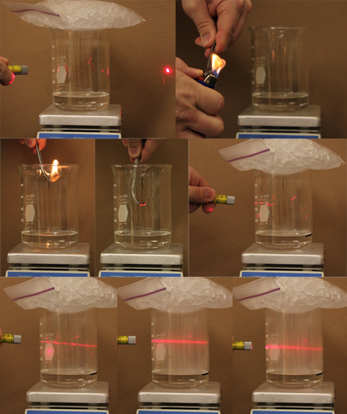

The process is somewhat complicated and the interested reader is referred to: http://en.wikipedia.org/wiki/Nucleation and http://en.wikipedia.org/wiki/Cloud_condensation_nuclei
Interestingly, physicists also use cloud chambers to detect the trajectories of subatomic particles. As the particles move through the chamber they nucleate tiny droplets, which form trails of mist, which allow scientists to observe them: http://en.wikipedia.org/wiki/Cloud_chamber

