Document ID: 12_04_01_2
Date Received: 2001-12-04 Date Revised: 2002-12-18 Date Accepted: 2002-12-20
Curriculum Topic Benchmarks: M4.3.9, M4.3.21, M4.3.22, M5.3.3, M5.3.4, M5.3.8, M5.3.13, M8.3.6
Grade Level: [6-8] Middle School
Subject Keywords: contour, contouring, topography, cross section, elevation, visualization, estimation, slope, 3 dimensions, 3 dimensional, algebra
Rating: moderate
Cross Section and Slope

By: Lorraine Remer Code 913, NASA/Goddard Space Flight Center, Greenbelt MD 20771 e-mail: remer@climate.gsfc.nasa.gov

From: The PUMAS Collection http://pumas.jpl.nasa.gov
©2002, California Institute of Technology. ALL RIGHTS RESERVED. Based on U.S. Gov't sponsored research.

Introduction: I introduce the concept of contour plots in the PUMAS example called Contouring and Topo Maps. Contouring is a fun way to help students develop estimation and spatial visualization skills. With contouring you imagine yourself looking down at a landscape and trying to represent hills and valleys on a flat map. The next step is to try to visualize what you see if you take a vertical slice, a cross section, out of your landscape.

These two companion PUMAS examples: Contouring and Topo Maps, and Cross Section and Slope, are envisioned as part of a mathematics curriculum. Students should be in their final year of basic mathematics before beginning Algebra or pre-Algebra. They should have mastered the 4 basic operations, and be comfortable with fractions and decimals. Students at this point are often looking for math enrichment, outside the scope of their textbooks. The concepts and exercises suggested by these two PUMAS examples are inherently mathematical and prepare students for higher-level concepts in Algebra, Geometry and Calculus. Similar exercises may be found in Earth Science textbooks, which may not stress the general mathematical principles of contouring and slope.

How to draw a cross section

Figure 1 is a contour plot of a simple symmetrical hill. The numbers represent the elevation (in meters) of that particular point in the landscape. Let’s say the points are separated by 100 m in the horizontal. The dark lines are contours, lines of constant elevation. In this case the contour interval is 10 m. If I walked along the dark lines, I would be walking along perfectly level paths. From my experience backpacking, this is the ideal way to travel on foot. You never have to walk uphill. However, there are always a few gung-ho hikers in every group who insist that the quickest path between point A and point B is a straight line.

The cross section along AB shows us the elevation change encountered by these gung-ho hikers. The cross section is plotted below the contour plot. Walking along the top of the cross section, they will start at an elevation of 15m, climb steadily to an elevation of 30 m and then descend back to 15m. They will do this as they travel 400 m in the horizontal. The plot is constructed simply by plotting the five elevation numbers (15, 25, 30, 25, 15) encountered along the AB line, spacing them by 100 meters along the horizontal axis.
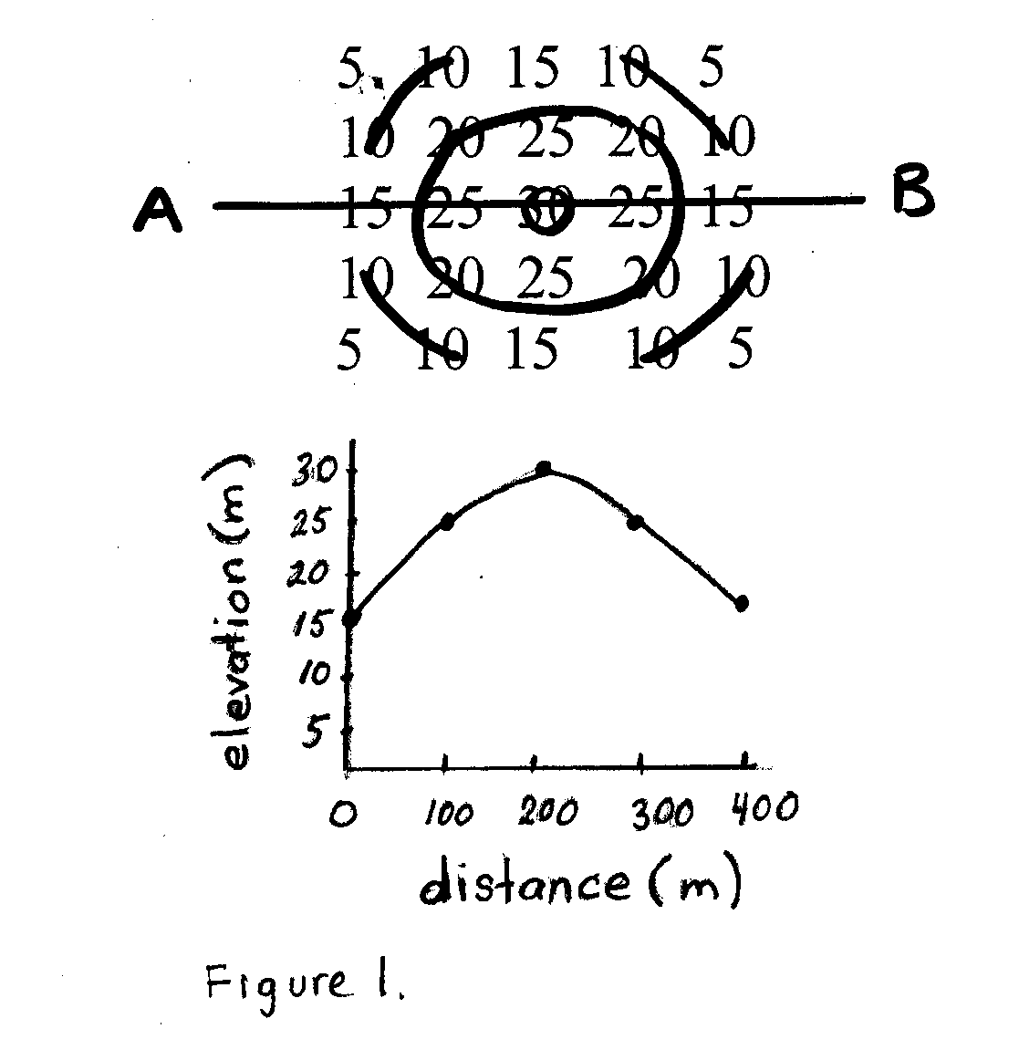

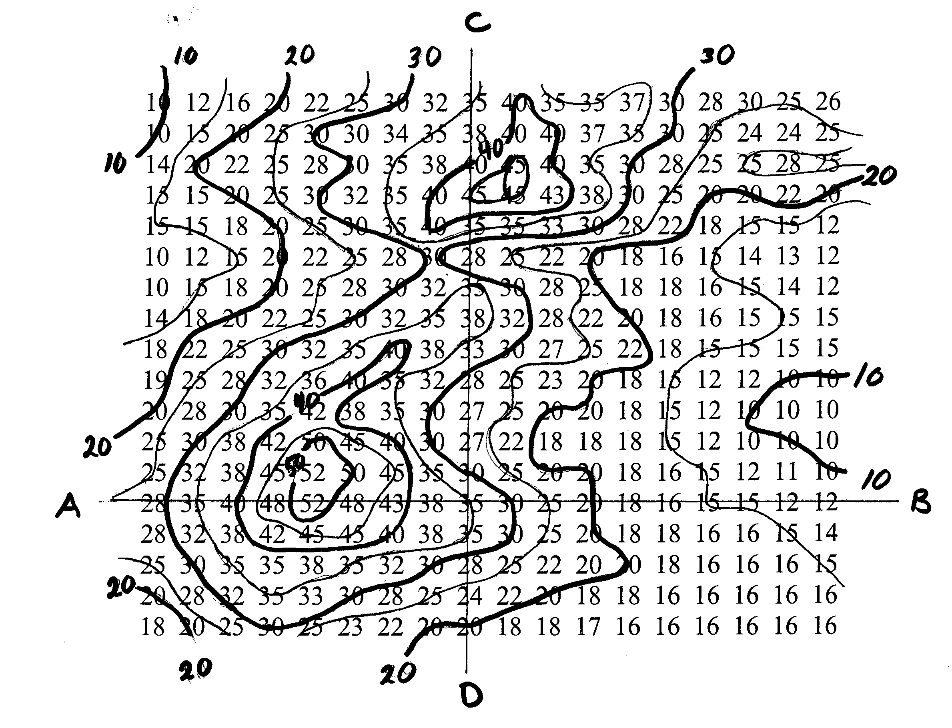

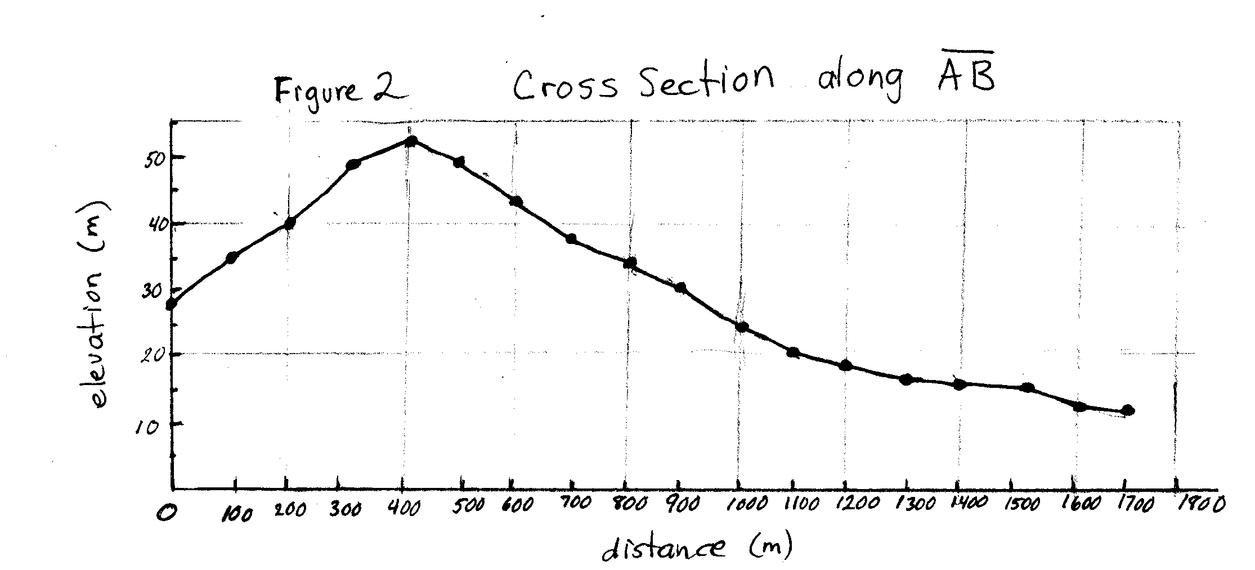

Figure 2 is based on a more complicated landscape that I contoured using a dark pen at a 10 m contour interval and using a lighter pen at a 5 m contour interval. Figure 2 is the cross section along line AB. Each dot represents an elevation number, spaced evenly at 100 m in the horizontal. To walk from A to B, first you climb from an elevation of 28m to a peak of 52 m and then descend to a gradual plain, ending at 12 m elevation 1700 m from your starting point.

You actually don’t need the elevation numbers to draw a cross section. Figure 3 shows a contour map of a double-peaked mountain, without the underlying elevation numbers. The cross section along line AB is shown in the second panel for contour interval of 5 m. Every time line AB intersects a contour curve, a dot is made immediately beneath the contour map on the cross section plot beneath. I use lightly drawn arrows to show how the point at 10 m on the left side of the mountain, and the point at 15 m on the right side of the mountain are transferred to the cross section plot. Without the underlying elevation numbers, the points on the cross section plot are not necessarily evenly spaced along the horizontal axis. Therefore, the cross section plot must be lined up exactly beneath the contour plot. I recommend using graph paper.

The third panel of Figure 3 shows what happens when you reduce resolution. Here I use a contour interval of 10 m (every second contour curve.) In the reduced resolution, we cannot resolve the twin peaks and are left with a broad flat mountain top.

The purpose behind drawing cross sections directly from the contour maps, without using the elevation numbers is to reinforce visualization concepts. Most contoured maps (USGS topo maps, or weather maps) do not include the elevation numbers. Students should be encouraged to visualize the cross sections from the contours alone.

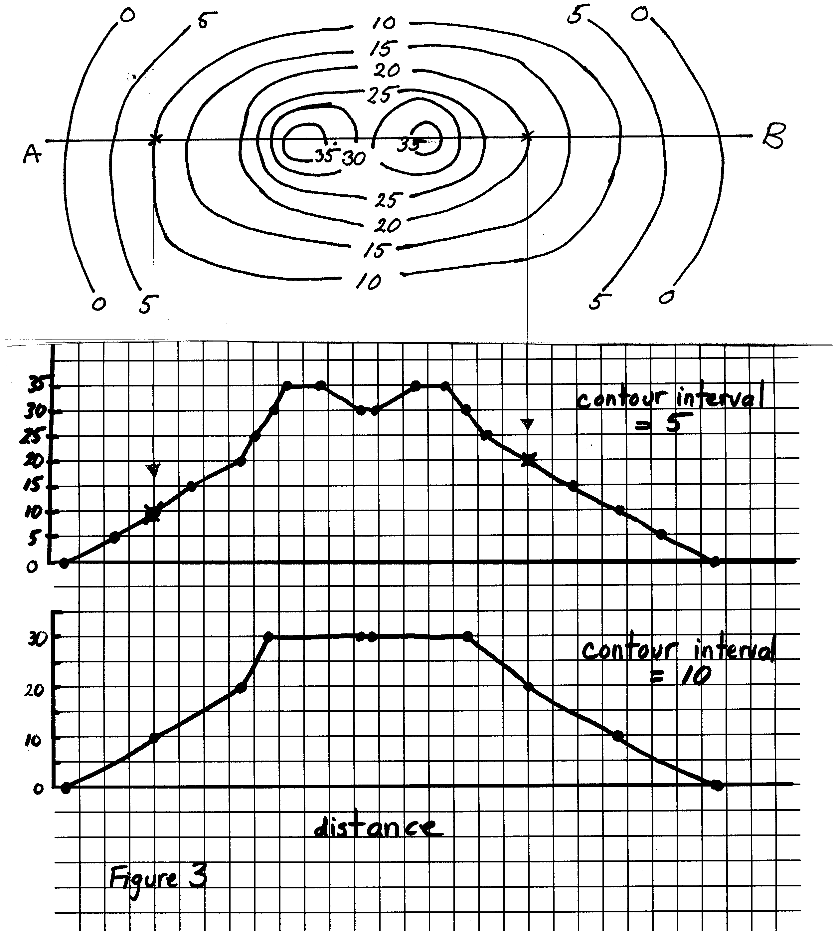

Suggested activities with a class

For suggested class activities, simply take all of the contour maps drawn with the Contouring and Topo Maps PUMAS example, designate a cross section line and have the students draw cross sections. Give a few examples of drawing from a contour plot with no elevation numbers. Give an example of drawing cross sections of the same topography, but contoured using different horizontal sampling intervals. Notice where slopes are steep and how this corresponds to the spacing of the contour lines. Slice the Play-doh model landscape to help explain the concept.

Slopes

The last step is to quantify this concept of “steepness” and call it slope. This is a more advanced concept, probably more appropriate at an Algebra level than in elementary school. However, I did introduce the mathematical concept of slope to a group of 5th graders and they did fine. At the end we went outside with a board, a level and a measuring tape to measure the slope of the playground slide and the slope of the steepest street in the neighborhood. If you would like to conclude a unit on contouring, cross section and slope with calculations of slope, I recommend any standard Algebra text for reference.

Note: A 44-page turn-key curriculum unit for this topic is available from the author.

