Measuring the Earth
Ted Bainbridge, Ph.D.

Finding the size of our planet does not require sophisticated technology, or distant travel as in ancient times. You can accomplish this task using a meter stick, a stopwatch, and some math. The process is described below, followed by examples and error analysis.

Measure time:

Lie on a firm flat surface and - USING ADEQUATE EYE PROTECTION - watch the sun go down. When the last edge of the sun goes below some point on the local horizon, start a timer. Stand up. Again watch the sun go down - USING ADEQUATE EYE PROTECTION - and when the last edge of the sun goes below that same point on the horizon, stop the timer.

Measure height:

Measure the height from the surface to the center of your eye. Lie down again and measure the distance from the surface to the center of your eye as it was when you watched the sun go down the first time. The difference between those two numbers is your effective height difference, labeled h in the drawing below.

Analyze the geometry:

In the drawing, the radius of the Earth is r. During the time you measured, the Earth’s radius beneath you moved from its starting location r_{s} to its final location r_{f}, sweeping out angle θ. Construct the right triangle dr_{s}r_{f}. Then the angle between the tangent line that includes segment d and the tangent line that is level also is θ.

The Pythagorean Theorem tells us d² + r_{s}² = (r_{f} + h)² so d² + r_{s}² = r_{f}² + 2r_{f}h + h². We know r_{s} = r_{f} so we can simplify to d² + r² = r² + 2rh + h². Since h << r, h² is negligible in comparison to r² and so can be ignored. Then we have d² = 2rh.

d/r = tan θ so d = r tan θ. When θ is measured in radians and is tiny, tan θ = θ so now we have d = rθ and therefore d² = r²θ². Immediately above we proved d² = 2rh so now we know
r²θ² = 2rh. Then our final result is r = 2h/θ². That is our formula for the Earth’s radius.

Analyze the proportions:

Write the proportionality between the amount the Earth rotated and the time that took:

θ degrees θ t seconds 360t seconds t
= = so θ = =
360 degrees 360 24 hours 24 x 60 x 60 seconds 240

When t is measured in seconds and θ is measured in degrees, θ = t/240. So when θ is measured in radians that becomes θ = (t/240) x (2π/360) so θ² = 5.2885 x 10⁻⁹ t². Then the Earth’s diameter is given by D = 2r = 4h/θ² = 756,358,583.1 h/t² where t is measured in seconds.

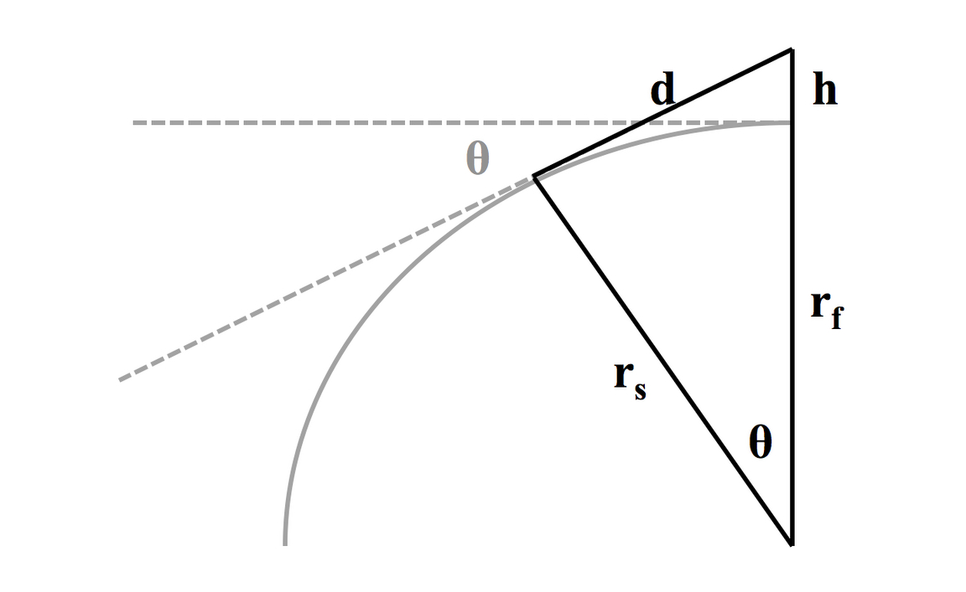

Numeric examples:

Suppose a person’s effective height difference is 5’6” (measured as 1.68 meters) and the time is measured as 10 seconds. Then the Earth’s calculated diameter is
D = 756,358,583.1 h/t² = 756,358,583.1 * 1.68 / 10² = 12,679,620.65 meters. The Earth is not a perfect sphere; the accepted value for its average diameter is 12,742,000.00 meters. So the above measurements produce a calculated error of 0.49 percent.

If a person’s effective height difference is 6’ and the time is 10.5 seconds, the Earth’s diameter is calculated to be 12,546,316.04 meters, which is an error of 1.54 percent.

Error analysis:

Measuring the two heights might include small errors. The error in measuring lying height and the error in measuring standing height add up to the error in h. If both errors are in the same direction and of the same size, there will be no error in h. If the errors are in different directions and/or of different sizes, the errors will add up to an error in h. Suppose a person’s true height difference is h₁ but is recorded as h₂ ≠ h₁. Since the Earth’s diameter D is a linear function of the effective height difference h, the percent error in h will produce the same percent error in D.

An error of  percent in h will create an error of  percent in D. For a person 1.8 meters tall, that would be a total of 9 millimeters of non-offsetting errors in measuring lying height and standing height. That accuracy should be easy to achieve.

Starting and stopping the timer might create small errors. A person’s motor reaction time to similar visual stimuli is an almost-constant delay. Therefore the recorded time should be very close to the actual time. Still, there might be a small error in the person’s behavior or an inaccuracy in the timer (such as rounding to the nearest tenth of a second instead of giving a precise reading). Suppose there is an error and the true time t is recorded as t+p where the error p is either positive or negative but not zero. D is an inverse quadratic function of t, so the percent error in D will be as follows. Students should prove this as an exercise.

2tp + p²
percent error in D = -
t² + 2tp + p²

The effect of the error depends on the correct time as well as on the error. To get some perspective on this effect, let’s rework an above example by injecting a time error of 0.2 seconds.

Suppose h = 5’6” as before but t = 10.2 seconds instead of 10.
Then D = 12,187,255.52 meters and the error is 4.35% instead of 0.49% (a shift of 3.86%).

Suppose h = 5’6” as before but t = 9.8 seconds instead of 10.
Then D = 13,202,437.16 meters and the error is 3.61% instead of 0.49% (a shift of 3.12%).

Thus we see that the impact of the timing error depends on the error’s direction as well as its size. These inconvenient characteristics are caused by the inverse quadratic relationship.

Modify the experiment:

We saw above that a reasonably small error in t has a greater impact than a reasonably small error in h. Can you think of a way to modify this experiment such that any error in t is a smaller percentage of t ? Discuss this with your lab partner, then carry out your modified experiment and compute your percentage of error in the diameter of our planet. Did your accuracy improve?

If none of the lab teams in your class can think of a modification, consider this hint. Suppose someone has a medical condition that confines that person to a wheelchair and makes great difficulty of lying down and then quickly standing up. Further suppose that the timer is started with the person seated, then two people help the person stand up to complete the experiment. If the person’s eyes are 4’1” up when seated and 5’6” up when standing, then h = 0.4318 meters. Then if recorded time is 5.05 seconds, D = 12,806,442.09 meters and the error is 0.51 percent. But if the time is erroneously recorded as 4.85 seconds the error becomes 8.97 percent. Compare those results to the preceding examples.

Develop a general principle:

After you have modified the experiment and achieved more accurate results, explain why your modification improved accuracy. Now think about doing an original experiment where the true result is not yet known. What general principle(s) related to measurement should you use in order to increase your confidence in the accuracy of your results?

Notes to teachers:

Increasing the precision of measurement methods and instruments decreases absolute error.

Enlarging what you measure decreases that absolute error as a percentage of the measured value.

Practicing reduces human error and variability, and so decreases absolute and relative error.

Measuring many times will either:
1. get the same result and thus increase confidence in your accuracy, or
2. show small variations which will let you “average out” your reported measurement, or
3. show large variations which indicate you need to improve your methods.

