Document ID: 03_23_02_1
Date Received: 2002-03-08 Date Revised: 2002-05-13 Date Accepted: 2002-05-14
Curriculum Topic Benchmarks: S12.4.7, M4.4.2, M4.4.3
Grade Level: [9-12] High School
Subject Keywords: aviation, force, dynamics, gravitation, Newton’s laws, catapult, aircraft carrier, velocity, acceleration
Rating: moderate

Launch Speed

By: Katherine Gateau, Education Student and US Navy Reserve Aircraft Maintenance Officer, 303 Richardson Way, Hanford, CA, 93230. E-mail: kgateau@bigfoot.com

From: The PUMAS Collection http://pumas.jpl.nasa.gov
©2002, California Institute of Technology. ALL RIGHTS RESERVED. Based on U.S. Gov't sponsored research.

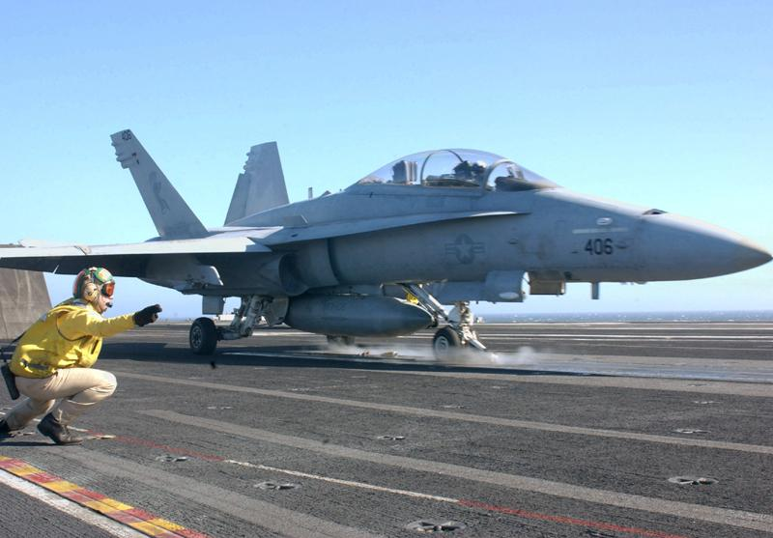

This example is a simple application showing how Newton’s laws of motions are used on aircraft carriers. As with any practical application of physics, it is important to be aware of your units of measure, and the meanings of all the terms in the equations.

How fast does a steam catapult have to travel to launch an aircraft?

Background: The wings of an aircraft are designed to generate “lift,” a force that opposes gravity and makes flight possible. The amount of lift produced depends on the velocity (speed) of the wind hitting the wing, a quantity we call “v,” measured in miles per hour or feet per second or meters per second. On US Navy aircraft carriers, steam catapults launch the planes. The catapults assist the engines in accelerating aircraft, to assure they are traveling fast enough to take off on the short shipboard runway.

For this example, the students play the role of catapult and arresting gear officers (also called “shooters”) on board an aircraft carrier. The shooter must determine the catapult settings for each launch, which depend on the aircraft type and weight, surface air density, and wind speed. In practice, shooters consult tables for help, but they are also required to know the physics behind the tables.

Exercise 1. Here’s a typical scenario: You are launching a F/A-18 Hornet with a full tank of gas and no weapons loaded. The takeoff weight is 40,000 lbs (178,000 N). How fast does the catapult shuttle have to travel to launch the aircraft so its Lift will overcome gravity and just equal the weight of the aircraft?

You are given the following information: The Lift equation says that the amount of lift depends on the air density, the wind velocity, and the surface area of the wings:

$L=\frac{1}{2}{ρv}^{2}s\text{cl}$

where L=lift in pounds (lbs) or Newtons (N), ρ (rho)=density of the air in slugs per cubic foot (slugs/ft³) or kilograms per meter cubed (kg/m³) (slug is the English mass unit), v= velocity of the wind hitting the wing in feet per second (ft/s) or meters per second (m/s), s=surface area of the wings in square feet (ft²) or meters squared (m²), and cl=coefficient of lift (unitless), which depends on the shape of the wing and the angle of attack (the angle between the wind vector and the plane of the wing), and can be considered a constant for this aircraft in this scenario.

For this example, we take ρ, s, and cl as constants, with ρ s cl=1.214 slugs/ft (58.127kg/m) [Editor’s note: Corrected from 615.739 kg/m in the original write-up]

Solution: To allow the aircraft to take off, Lift must overcome gravity and equal the weight of the aircraft. So the problem becomes a simple one-variable equation:

$v^{2}=\frac{2L}{ρs\text{cl}}$

In this case, v=256.7 ft/s (78.2 m/s). In actuality, this velocity is catapult speed + the speed of the plane’s headwind at takeoff, so we could easily account for the wind across the deck. If we assume there is no wind, it equals catapult speed.

Exercise 2. If the shooter makes a mistake and sets the catapult for the wrong speed, say 0.8v, can the airplane engines produce enough thrust to keep the plane from landing in the water?

You are given the following information: Maximum thrust for the two hornet engines (non-afterburner) is 22,000 lbs. (97,900 N), and at takeoff the pilot has already set the thrust to full power so reaction time is not an issue. The carrier deck is 80 feet (24.38 m) above the water, and the acceleration of gravity is g=32.2ft/s² (9.8 m/s²).

Solution: First, determine how much lift we are producing by substituting 0.8v into the lift equation, which works out to 25,600 lbs (113,920 N). After takeoff, the lift on the aircraft is 25,600/40,000 (113,920/178,000) = 64% gravity. So we are falling at an acceleration of 36% gravity = 0.36 * g = 11.58 ft/s² (3.53 m/s²).

Now we use the definition of acceleration (=a) to solve for the time (t) it takes to fall a height (h) of 80 feet (24.38 m). We assume the plane leaves the edge of the runway traveling horizontally, and for this part of the calculation, ignore the increase in the plane’s horizontal velocity, which generates more lift, during the few seconds after launch, (otherwise it becomes a calculus problem). Then $h=\frac{1}{2}{\text{at}}^{2}$, and you can solve for time to fall 80 feet:
$t=\sqrt{\frac{\text{80}}{\frac{1}{2}\text{11}\text{.}\text{58}}}=3\text{.}7s$ OR $t=\sqrt{\frac{\text{24}\text{.}\text{38}}{\frac{1}{2}3\text{.}\text{53}}}=3\text{.}7s$

Next, determine how much thrust (a quantity with units of force) is required to accelerate from 0.8v to v in 3.7 seconds. (It is convenient to use velocities in ft/s or m/s.)

To find the acceleration required:

Δv = a t

$a=\frac{\text{256}\text{.}7−\text{205}\text{.}4}{3\text{.}7}=\text{13}\text{.}9{\text{ft}}/{s^{2}}$ OR $a=\frac{\text{78}\text{.}2−\text{62}\text{.}6}{3\text{.}7}=4\text{.}2m/{s^{2}}$

To determine the thrust required, use Newton’s law. (Remember that lbs = slugs*ft/s² and N = kg*m/s²).

F = m a

Mass of aircraft = 40,000 lbs / 32.2 ft/s² = 1,242.2 slugs
= 178,000 N / 9.8 m/s² = 18,163.3 kg

F= 1,242.2 * 13.9 = 17,266 lbs
= 18,163.3 * 4.2 = 76,285.9 N

This is less than the actual engine thrust, 22,000 lbs. (97,900 N), so in this scenario the engines provide enough thrust.

Exercise 3. At maximum thrust, how far above the water are you when you start to climb? (As in exercise 2, ignore the fact that as you generate more lift, so you are not actually falling as fast; assume all the lift occurs when you start to climb.)

Solution: a=F/m=22,000/(40,000/32.2)=17.7 ft/s² or a=F/m = 97,900/(178,000/9.8)=5.4 m/s². So, the time until we generate lift is:
t = Δv / a = 51.3 / 17.7 = 2.9 s or 15.6/5.4 = 2.9 s, and we will fall:

$h=\frac{1}{2}{\text{at}}^{2}$= $\frac{1}{2}$ * 11.58 * 2.9² = 48.7 ft, which is only 31.3 ft above the water.
Or
$h=\frac{1}{2}{\text{at}}^{2}$= $\frac{1}{2}$ * 3.53 * 2.9² = 14.8 m, which is 9.5 m above the water.

Exercise 4. Given that the length of the steam catapult (d) is 309 ft (94.2 m), and assuming the aircraft starts from rest and the catapult exerts a constant force on the aircraft, what “g force” does the pilot experience just before takeoff?

Solution: In addition to the length of the catapult, we can use the value for v we calculated in the first exercise, 256.7 ft/s or 78.2 m/s. Acceleration will be constant because force and mass are constant. Using two motion equations we are already familiar with, we can solve a system of two equations with two unknowns:

Δv = a t

$d=\frac{1}{2}{\text{at}}^{2}$

And solve for t=2.41s and a=106.64 ft/s² or 32.5 m/s². If we divide the aircraft’s acceleration by the acceleration of gravity, we get 3.3 g’s experienced by the pilot in this case, meaning that all the pilot’s body parts and internal organs seem to weigh three times as much as normal. (Which actual hornet pilots confirm is in the right ballpark.)

